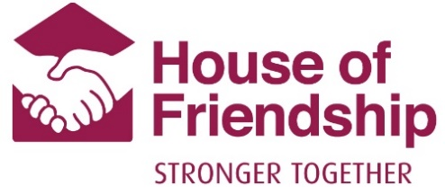

Media Release: Community Partners Launch ‘House of Hope’ to Provide Temporary Shelter During COVID-19
For Immediate Release
Ray of Hope and House of Friendship are excited to be working together to provide a temporary emergency shelter to men experiencing homelessness in Waterloo Region at the new ‘House of Hope.’
Operating out of Ray of Hope’s Community Centre (230-659 King St. E.), House of Hope will welcome up to 28 men per night, providing a place of refuge and shelter for those who have nowhere else to go during the COVID-19 pandemic. Ray of Hope and House of Friendship will jointly staff the temporary shelter with funding provided from the Region of Waterloo.
House of Hope will include a safe sleeping space, access to snacks and meals, a supportive environment with caring and non-judgmental staff, computer lab, WIFI and access for personal laundry and shower facilities.
Together, Ray of Hope and House of Friendship have a combined 134 years of experience in caring for the most vulnerable in Waterloo Region, making this partnership a natural fit.
“Collaboration has always been key to our success, and we have always had a strong relationship with House of Friendship so this was a natural partnership,” said Tonya Verburg, CEO at Ray of Hope. “Our teams have come together and are truly caring for the men being supported at House of Hope in a holistic, empowering way.”
“This is the kind of innovation and partnership that Waterloo Region is known for,” said Jessica Bondy, House of Friendship Housing Director. “COVID-19 has made the problem of housing and homelessness even more acute in our region, and this community is determined to rise to the challenge. This new partnership between House of Friendship and Ray of Hope builds on a legacy of collaboration between our two organizations and will provide a safe haven for those who need it most. We’re so honoured to be part of that.”
House of Hope will initially accommodate those who accessed the temporary emergency shelter at the A.R. Kaufman Family YMCA. The Y is now preparing to convert that space to offer day camp programs to support children and families this summer.
-30

For more information, contact:
Jessica Bondy  Housing Director  House of Friendship  jessicab@houseoffriendship.org | Tonya Verburg  CEO  Ray of Hope  tverburg@rayofhope.net
About Ray of Hope: Ray of Hope has been providing hope for those struggling with crime, addiction, and poverty in the Waterloo Region since 1967 - www.rayofhope.net
About House of Friendship: Founded in 1939, House of Friendship serves Waterloo Region with a vision to build a healthy community where everyone can belong and thrive. Each year, House of Friendship supports more than 42,000 people who need food, housing, addiction treatment or access to vital community resources. For more information, visit www.houseoffriendship.org.

